**Linux Commands**

**1. pwd**

The pwd command shows the full path to the current working directory.



**2. vi**

Vi is a command line text editor. You can use the **vi** editor to edit an existing file or to create a new file from scratch. You can also use this editor to just read a text file. There are two modes in Vi. **Insert** (or Input) mode and **Edit** mode. In input mode you may input or enter content into the file. In edit mode you can move around the file, perform actions such as deleting, copying, search and replace, saving etc.

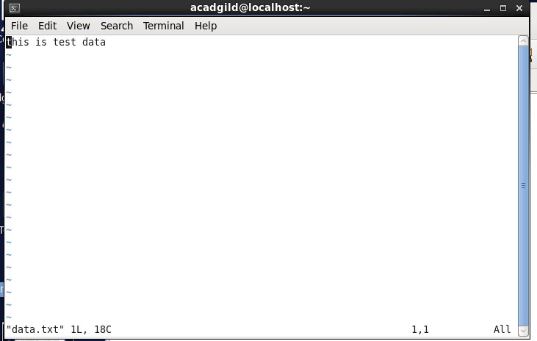

**3. touch**

The touch command is the easiest way to create new, empty files. It is also used to change the timestamps (i.e., dates and times of the most recent access and modification) on existing files and directories.

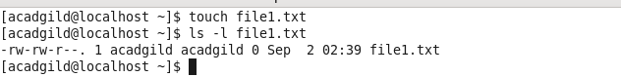

**4. mkdir**

The mkdir create the DIRECTORY(ies), if they do not already exist.

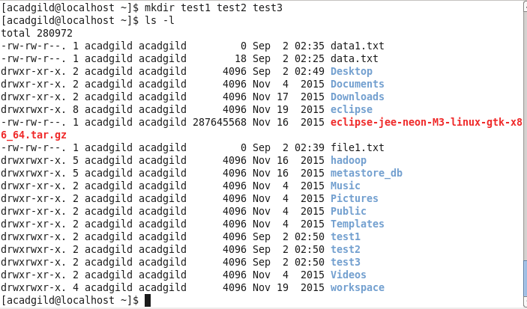

**5. rm**

The *rm* (i.e., *remove*) [command](http://www.linfo.org/command.html) is used to delete files and directories .

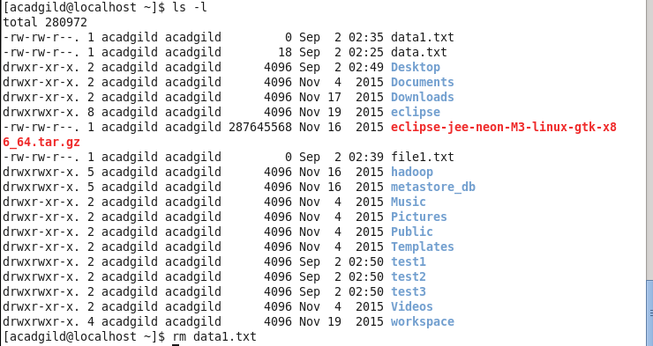

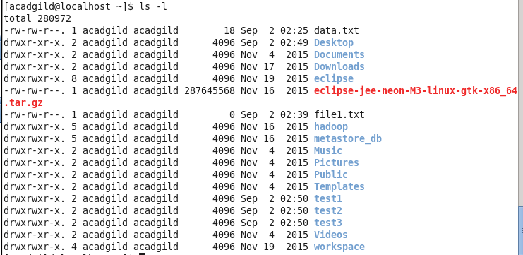

As a safety measure, rm does not delete directories by default. In order to delete directories, it is necessary to use the *-r* option, which is the same as the *-R* option. This option *recursively* removes directories and their contents in the [argument](http://www.linfo.org/argument.html) list; that is, the specified directories will first be emptied of any subdirectories (including their subdirectories and files, etc.) and files and then removed.

**6. ls**

“ls” command is used to list directory contents.

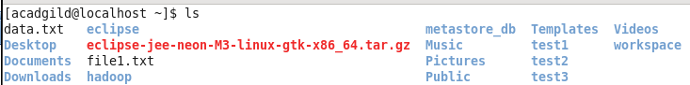

**7. echo**

echo is a built-in command in the bash and C shells that writes its arguments to standard output.



Echo is particularly useful for showing the values of environmental variables, which tell the shell how to behave as a user works at the command line or in scripts (short programs).

For example, to see the value of HOME, the environmental value that shows the current user's home directory, the following would be used:



**8. cat**

The cat (short for “concatenate“) command allows us to view contents of file, concatenate files and redirect output in terminal or files.



**9. who**

The who command prints information about all users who are currently logged in.****

**10. cd**

The cd command, also known as chdir (change directory) is used to change your working directory.



**11. date**

The date command is used to print out, or change the value of, the system's time and date information.



**12. cal**

The cal command display a conveniently-formatted calendar from the command line.

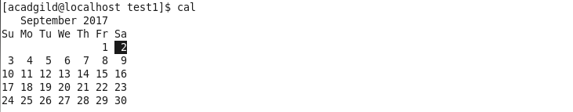

**13. mv**

The **mv** (move) command is used to move or [rename](https://www.computerhope.com/jargon/r/rename.htm) files.

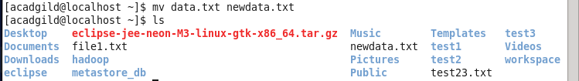

**14. cp**

The **cp** command is used to make copies of files and directories.

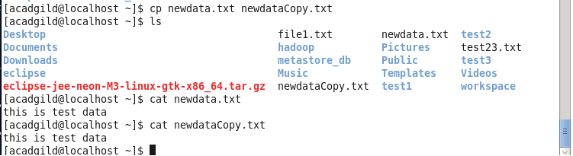

**15. which**

Which command is command to locate executables in the system. “which” commands searches the path of executable in system paths set in $PATH environment variable.

